Q1. What is Cloud Computing? Explain essential characteristics of Cloud Computing. [10]

Cloud computing is a model for enabling ubiquitous, convenient, on-demand network access to a shared pool of configurable computing resources (e.g., networks, servers, storage, applications, and services) that can be rapidly provisioned and released with minimal management effort or service provider interaction. This cloud model is composed of five essential characteristics, three service models, and four deployment models.

It means that the computing resource or infrastructure—be it server hardware, storage, network, or application software—all available from the cloud vendor or provider’s site/premises, can be accessible over the Internet from any remote location and by any local computing device. In addition, the usage or accessibility is to cost only to the level of usage to the customers based on their needs and demands, also known as the pay-as-you-go or pay-as-per-use model. If the need is more, more quantum computing resources are made available (provisioning with elasticity) by the provider

Five Essential Characteristics

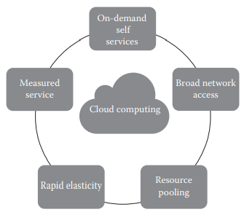

1. On-demand self-service: A consumer can unilaterally provision computing capabilities, such as server time and network storage, as needed automatically without requiring human interaction with each service’s provider.
2. Broad network access: Capabilities are available over the network and accessed through standard mechanisms that promote use by heterogeneous thin or thick client platforms (e.g., mobile phones, laptops, and personal digital assistants [PDAs])
3. Elastic resource pooling: The provider’s computing resources are pooled to serve multiple consumers using a multitenant model, with different physical and virtual resources dynamically assigned and reassigned according to consumer demand. There is a sense of location independence in that the customer generally has no control or knowledge over the exact location of the provided resources but may be able to specify the location at a higher level of abstraction (e.g., country, state, or data center). Examples of resources include storage, processing, memory, and network bandwidth.
4. Rapid elasticity: Capabilities can be rapidly and elastically provisioned, in some cases automatically, to quickly scale out and rapidly released to quickly scale in. To the consumer, the capabilities available for provisioning often appear to be unlimited and can be purchased in any quantity at any time.
5. Measured service: Cloud systems automatically control and optimize resource use by leveraging a metering capability at some level of abstraction appropriate to the type of service (e.g., storage, processing, bandwidth, and active user accounts). Resource usage can be monitored, controlled, and reported providing transparency for both the provider and consumer of the utilized service.

Q2. Explain Cloud Computing reference model with neat diagram. . [10]

**Kindly Explain each concepts in your own words**

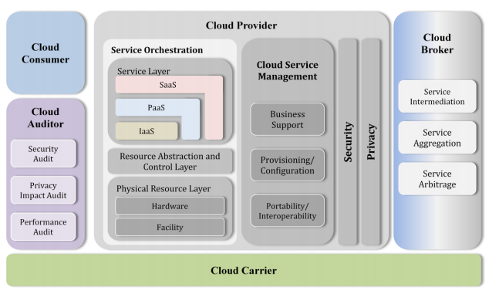

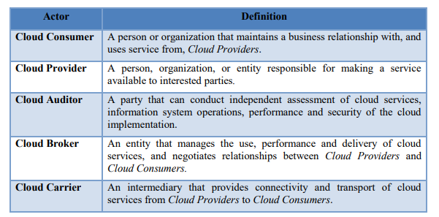

Q3. Write short note on : [10]

1. Private Cloud

According to the National Institute of Standards and Technology (NIST), private cloud can be defined as the cloud infrastructure that is provisioned for exclusive use by a single organization comprising multiple consumers (e.g., business units). It may be owned, managed, and operated by the organization, a third party, or some combination of them, and it may exist on or off premises . The private cloud in simple terms is the cloud environment created for a single organization. It is usually private to the organization but can be managed by the organization or any other third party.. The private cloud is small in size as compared to other cloud models. Here, the cloud is deployed and maintained by the organizations itself

Characteristics Certain characteristics of the private cloud are as follows:

1. Secure: The private cloud is secure. This is because usually the private cloud is deployed and managed by the organization itself, and hence there is least chance of data being leaked out of the cloud. In the case of outsourced cloud, the service provider may view the cloud (though governed by SLAs), but there is no other risk from anybody else as all the users belong to the same organization.

2. Central control: The organization mostly has full control over the cloud as usually the private cloud is managed by the organization itself. Thus, when managed by the organization itself, there is no need for the organization to rely on anybody.

3. Weak SLAs: Formal SLAs may or may not exist in a private cloud. But if they exist they are weak as it is between the organization and the users of the same organization. Thus, high availability and good service may or may not be available. This depends on the organization that is controlling the cloud.

Suitability

The organizations or enterprises that require a separate cloud for their personal or official use.

• The organizations or enterprises that have a sufficient amount of funds as managing and maintaining a cloud is a costly affair.

• The organizations or enterprises that consider data security to be important.

• The organizations that want autonomy and complete control over the cloud.

• The organizations that have a less number of users.

• The organizations that have prebuilt infrastructure for deploying the cloud and are ready for timely maintenance of the cloud for efficient functioning.

• Special care needs to be taken and resources should be available for troubleshooting

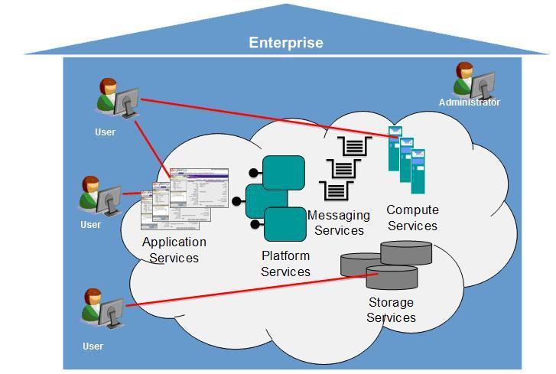

Advantages of Private Cloud

Medium and large businesses typically chose a private cloud due to its protection, compliance, and scalability options. Other benefits include

* Fine-grained control over your infrastructure.
* Adapt better to the usage of resources as per demand.
* If your business has to comply with bespoke industry standard compliance, the private cloud allows you to easily ensure your systems are totally compliant.
* While you can scale to demand in a public cloud, the granularity of scale that the private cloud offers is of a significant benefit for some businesses.
* Large to very large businesses might want to maintain a private cloud then use a public infrastructure especially with a competitor on it or the infrastructure itself owned by a competitor.

Disadvantages of Private Cloud

* the associated cost. In general private clouds are more expensive than public
* Operational efficiency in a private cloud is difficult to achieve. Underutilization is a major grouse in private clouds.
* Scaling up on hardware and real estate space would be a challenge in private clouds.

Private Cloud Companies in market

Hewlett Packard Enterprise (HPE)

VMware

Dell EMC

Oracle

IBM

Red Hat

1. IAAS

IaaS changes the way that the compute, storage, and networking resources are consumed. In traditional data centers, the computing power is consumed by having physical access to the infrastructure. IaaS changes the computing from a physical infrastructure to a virtual infrastructure. IaaS provides virtual computing, storage, and network resources by abstracting the physical resources. Technology virtualization is used to provide the virtual resources. All the virtual resources are given to the virtual machines (VMs) that are configured by the service provider. The end users or IT architects will use the infrastructure resources in the form of VMs as shown in Figure

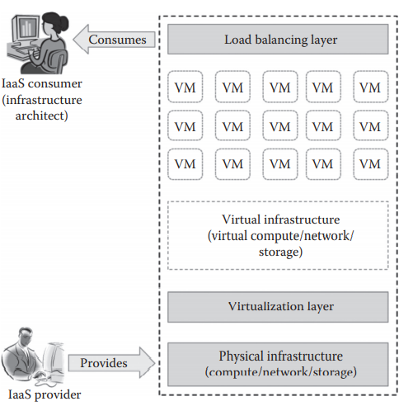

* Generally, the IaaS services are provided from the service provider cloud data center.
* The end users can access the services from their devices through web command line interface (CLI) or application programming interfaces (APIs) provided by the service providers.
* Some of the popular IaaS providers include

Amazon Web Services (AWS)

Google Compute Engine

OpenStack

Eucalyptus.

Services provided by IaaS providers

* **Compute:** Computing as a Service includes virtual central processing units (CPUs) and virtual main memory for the VMs that are provisioned to the end users.
* **Storage:** STaaS provides back-end storage for the VM images. Some of the IaaS providers also provide the back end for storing files.
* **Network:** Network as a Service (NaaS) provides virtual networking components such as virtual router, switch, and bridge for the VMs.
* **Load balancers:** Load Balancing as a Service may provide load balancing capability at the infrastructure layer.

Characteristics of IaaS

* Web access to the resources
* Centralized management
* Elasticity and dynamic scaling
* Shared infrastructure
* Preconfigured VMs
* Metered services

Suitability of IaaS

* Unpredictable spikes in usage
* Limited capital investment
* Infrastructure on demand

Benefits provided by IaaS

* Pay-as-you-use model
* Reduced TCO
* Elastic resources
* Better resource utilization
* Supports Green IT

Drawbacks of IaaS

* Security issues
* Interoperability issues
* Performance issues